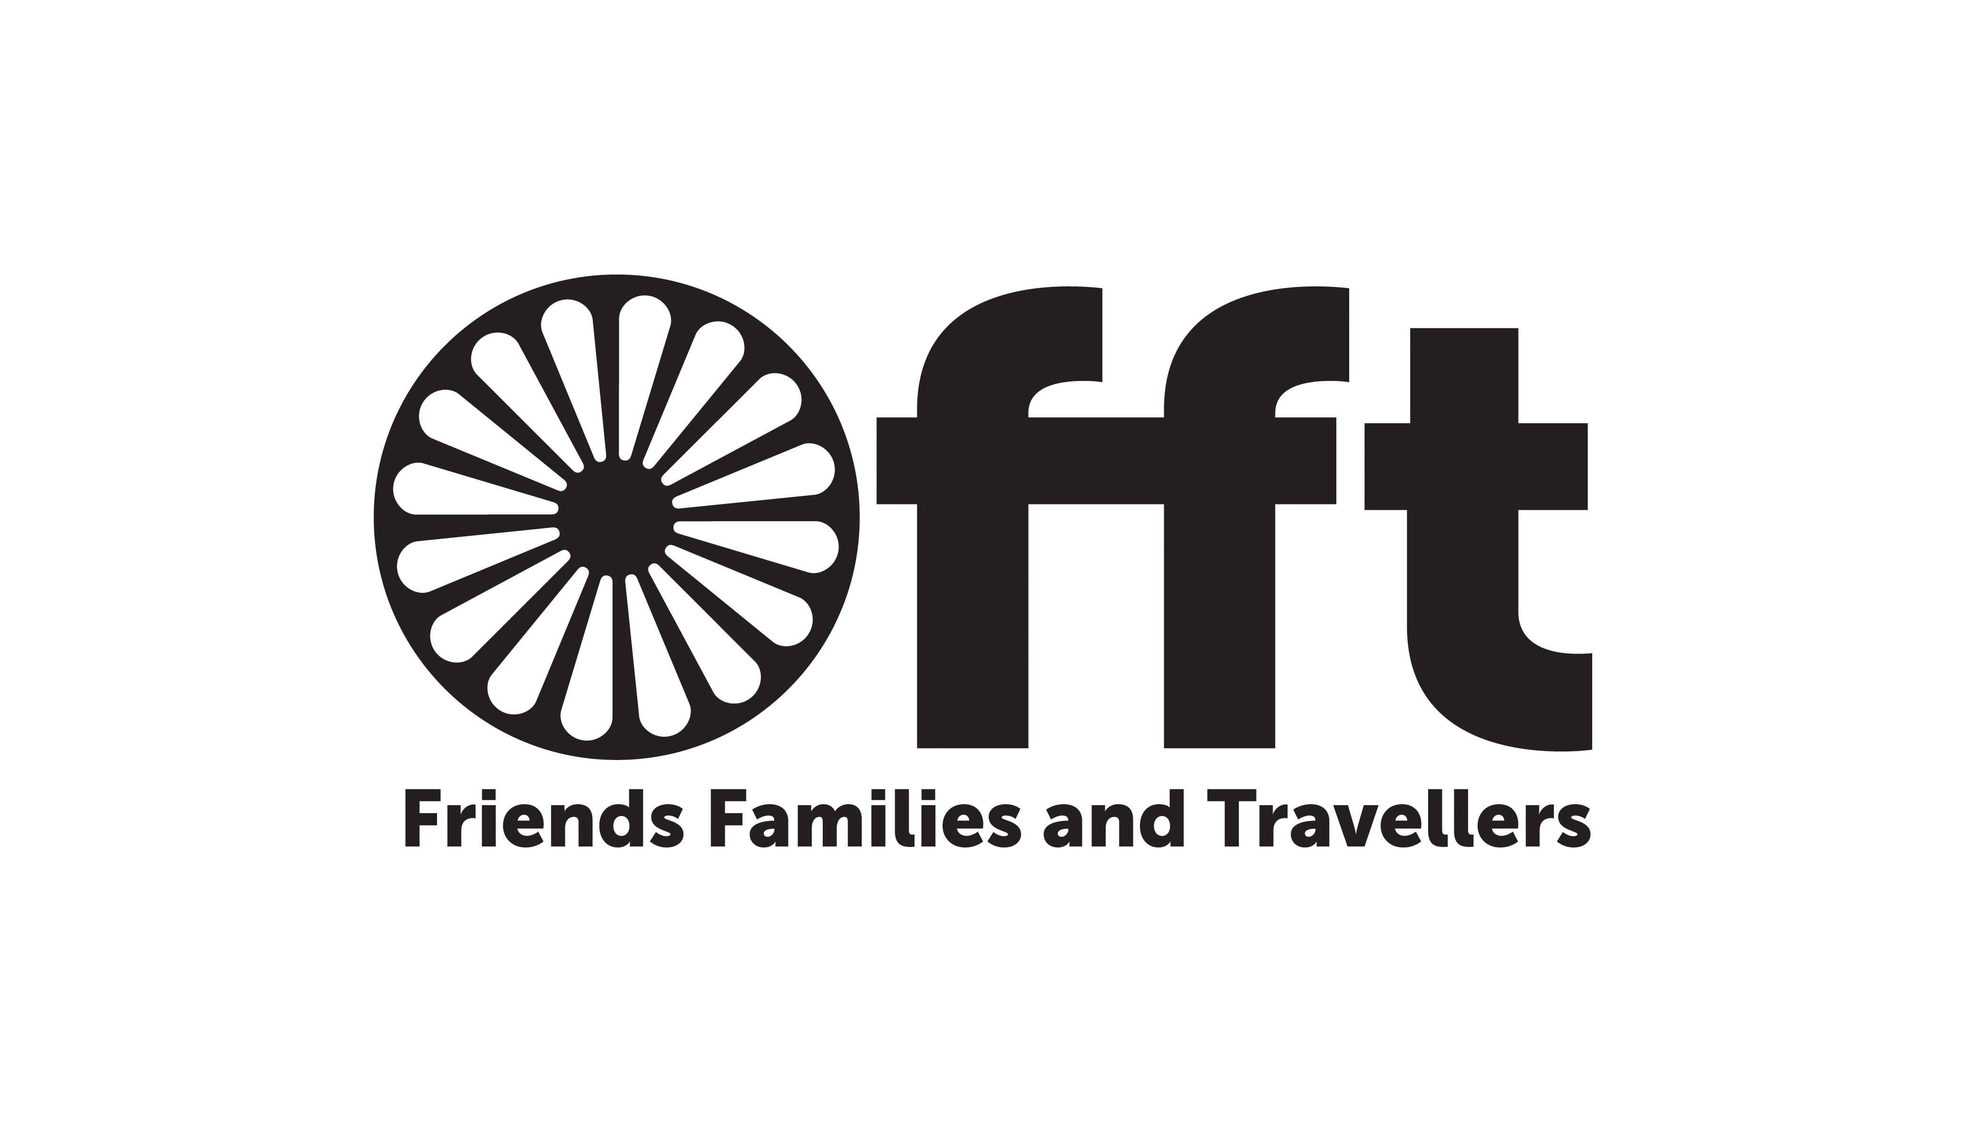
Application Form
Friends, Families and Travellers
App Number
Date Arrived

Post Applied For
Where did you see this post advertised
If appointed, when could you start

Section A: Personal Details
Surname
Forename / s
Address
Town
Post Code
Home Tel
Work Tel
Mobile
Email

Section B: References
Please give the names and addresses of two persons, other than relatives, who we can approach for references. E.g. a college tutor
Referee 1 |  | Referee 2
Full Name |  | Full Name
Position |  | Position
Organisation |  | Organisation
Address |  | Address
Town |  | Town
Post Code |  | Post Code
Telephone |  | Telephone
Relationship |  | Relationship

Section C: Confirmation
I confirm that to the best of my knowledge the information in this form is accurate.
Signed |  | Date
Section D: Skills, knowledge, abilities and experience
- What skills do you have? Experience is not just gained from full time work, it can also be from voluntary or part-time work, college or school based projects, or home life etc.
- Give practical examples where appropriate of your ability, commitment, knowledge and experience by some reference to your academic, professional, voluntary or personal/ family life.
E.g. I can send and receive emails/ I am a keen photographer/ I have a blog/ I am a competent car mechanic

- What skills/opportunities would you like to develop or find out more about during the
Internship?
E.g. I would like to find out about the courses on offer at Plumpton college/ I would like to
meet a tree surgeon and ask them about their work/ I would like to visit the Houses of
Parliament.

Section E: Education and Training
Please list the examinations, qualifications, relevant training courses, workshops, etc that you feel are relevant to this post.
Venue | Course | Award

Section F: Employment History
Dates  From / To | Employer Name  Employer Address | Job Title  Description  Remuneration  Reason for leaving
Please return this form to Liz MacPherson by email to liz@gypsy-traveller.org

If you cannot send by email, please post to Friends, Families & Travellers
Community Base
113 Queens Road
Brighton
BN1 3XG

